Accessibility Tips for Digital Course Materials

For documents, images, web pages, and videos:
- Use clear, consistent page arrangements for documents and slides.
- Use the structured heading styles built into your software—Heading 1, Heading 2, Heading 3, Normal, and so on. You can customize the fonts, sizes, styles, and colors. Contrasting size and weight will make the hierarchy of headings more distinct. A structured hierarchy of headings makes keyboard navigation easier for people using screen readers such as JAWS, Window-Eyes, and NVDA.
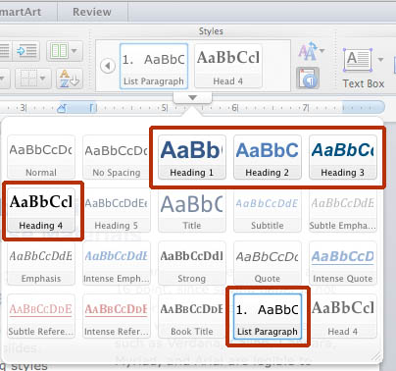
Figure 1—This screen shot shows the heading style choices that have been used in this document.
- For hyperlinks, use descriptive text such as Accessible Media Link instead of Click Here.
- Avoid presenting text as an image, such as a scan or photograph. If your page is a PDF, make sure that the text can be selected and copied.
- Write alternative texts for images (alt-tags) describing content you want students to learn. These tags will be accessible to students with impaired vision who use screen readers.
- Use large text sizes, even 14 and 16 point, since saving paper is not a priority for digital pages.
- Use shorter lines, with fewer words—10 or 11 at most. Try double columns. These are easier to read on smart phones.
- Use color combinations with strong light-dark contrast that can be differentiated by people with impaired color vision.
- Make sure all content and navigation is accessible by use of the keyboard alone, and does not require use of a mouse or trackball.
- Since people with impaired hearing cannot hear the sound in videos, use videos that have closed captioning built-in, or else inquire if you can have your school purchase captioning.
- Fonts with monoweight strokes such as Verdana, Calibri, Candara, Myriad, and Arial are legible to more readers than fonts with strokes that taper from thick to
thin such as Times New Roman. This is why computer interfaces tend to use fonts with monoweight strokes.

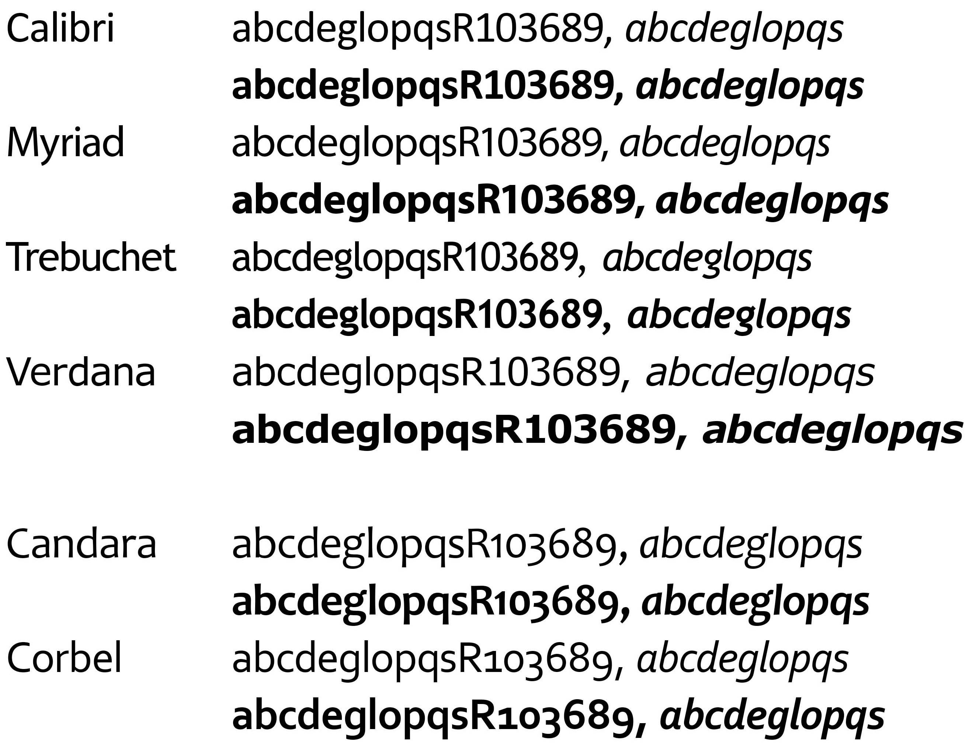
Figure 2—This image shows six recommended font families that have monoweight strokes, and styles for normal, italic, bold, and bold italic. The first four, Calibri, Myriad, Trebuchet, and Verdana, have capital numbers. The other two, Candara and Corbel, have the lower-case numbers that are good in text-heavy documents.

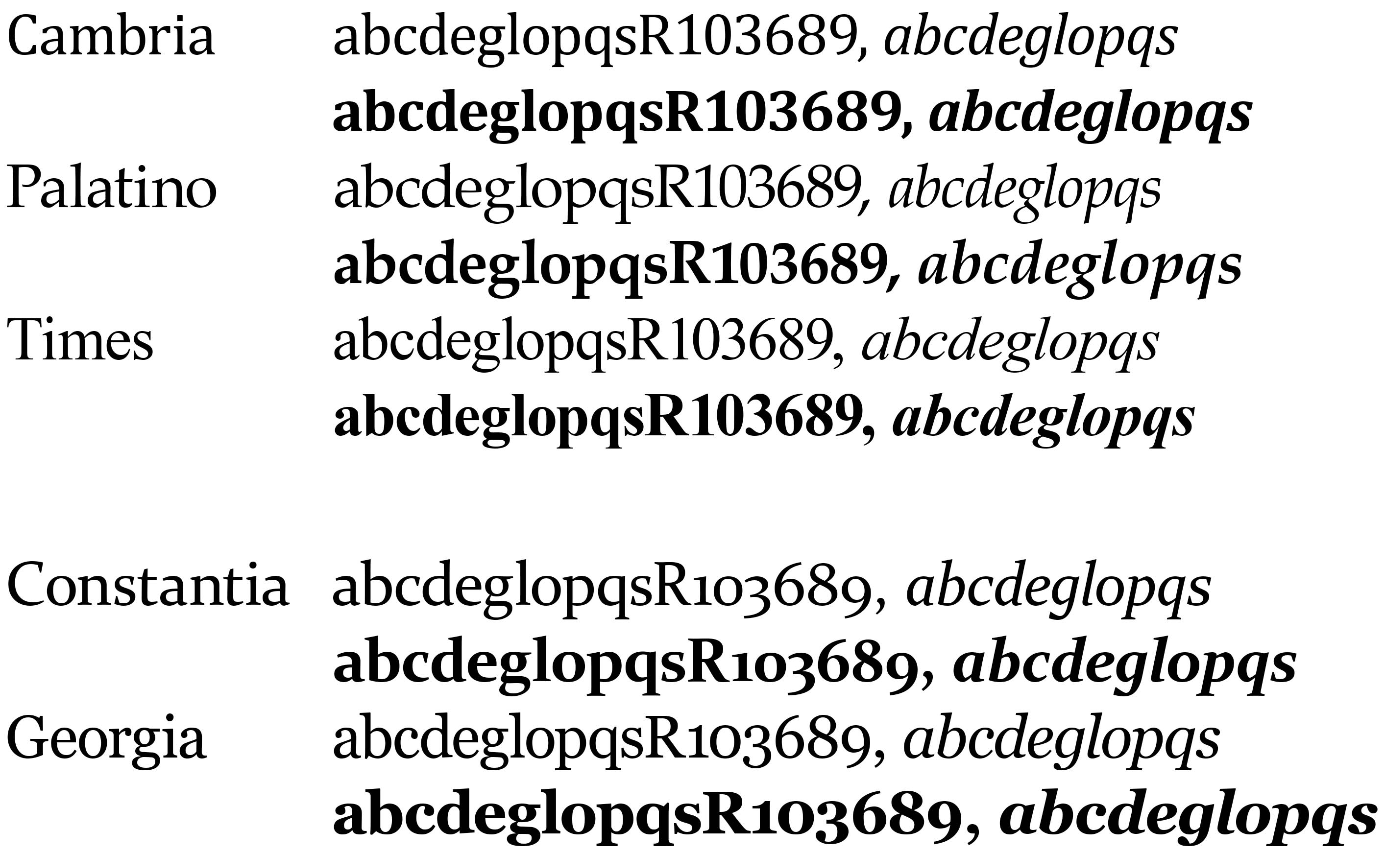
Figure 3—Tapered Stroke Fonts. Cambria, Palatino, and Times feature capital numbers. Constantia and Georgia offer lower-case numbers.

Universal Design for Learning:
Basic Concepts

- Design your document, or your course, to be accessible to a wide range of abilities and learning styles. If you are a teacher, assume that some students have invisible disabilities, but have not registered for Learning Accommodations, and won’t disclose their disability to you.
- Seek to make course content available in multiple formats, or modes, including printed text, digital text, audio, video, and images.
- Provide essential course materials such as the syllabus, assignment schedule, and assignment descriptions, both as hard copy, and as digital files posted in Blackboard or other learning management system. Students that lose hard copies will need easy access to the digital versions.
- Recognize that literacy skills and vocabularies of some students are still developing, so avoid jargon and acronyms, and provide explanations or definitions when possible.
- Try to use images to augment course content. Students understand and remember content better when delivered with a combination of words and pictures. On the syllabus, add a map, your portrait, and images of textbook covers.
- Make instructions and expectations clear for assignments. Provide examples of the kind of work the student will be doing.
- Design assignments to allow options for student expression, including writing, speaking, slide shows, video, and image-making.
- Offer outlines, glossaries, overviews, and other scaffolding tools to help students navigate the coursework.
- Allow adequate time for practice, projects, and tests.
- Let students receive feedback from each other and from you, the instructor, and then provide opportunities for students to make corrections and improvements.

Microsoft Word

Accessibility Tips
These routine practices can bring your documents into compliance with the Americans With Disabilities Act.

Use document styles
Use heading and paragraph styles to structure the document.

Add alt-text to images and objects
This includes pictures, clip art, charts, shapes, SmartArt graphics and embedded objects. Use clear, concise terms. For example, “Person in wheelchair on ramp” may suffice rather than “Smiling woman in wheelchair posing on ramp.”

Use short titles in headings
Keep headings short (fewer than 20 words or one line long). This makes it easy for readers to quickly navigate your document.

Name your hyperlinks appropriately
Your link should contain meaningful text that reflects the link destination or subject, rather than simply saying “click here.”

Use simple table structure
Avoid using nested tables, merged or split cells, or blank cells for formatting.

Set column header rows in tables
Clear column headings provide context and assist navigation of the table contents. Bookmarks are also a useful tool.

Avoid using repeated blank characters
Extra spaces, tabs and empty paragraphs can cause people using screen readers to repeatedly hear the word “blank.” Instead, use styles with formatting and indenting to create white space.

Avoid using floating objects
Place objects in-line with text for easy navigation.

Avoid watermarks
Watermarks and other background images may be hidden or confusing to people with vision or cognitive disabilities. Instead of using a watermark to identify a document as a “draft” or “confidential,” include the text in the document title or heading.

Fill in document properties
In advanced document properties, enter title, subject, and author.

Use the Accessibility Checker
This built-in tool will tell you about possible accessibility issues in your document and give suggestions on how to correct them.

Microsoft Excel

Accessibility Tips
These routine practices can bring your documents into compliance with the Americans With Disabilities Act.

Give all sheet tabs unique names
Sheet names should provide information about what is found on the worksheet, making it easier to navigate through a workbook. Remove blank sheets.

Enter title in first row and column
You may merge cells to center the title.

Add alt-text to images and objects
This includes pictures, clip art, charts and embedded objects. Use clear, concise terms. For complex charts and diagrams, provide a data table or a link to the data table.

Specify row and column headings.
Use cell styles when appropriate. Clear headings provide context and assist navigation of the table contents.

Use color carefully
High contrast color schemes and texture variations in graphs improve readability. Test your designs by printing in black & white.

Hide Unused Rows and Columns
This prevents screen reader users and keyboard navigators from wandering off into blank cells.

Name your hyperlinks appropriately
Your link should contain meaningful text that reflects the link destination or subject, rather than simply saying “click here.”

Use alignment tools for layout and to create white space
Don’t use blank rows/columns for spacing. Manage your layout by resizing rows and columns, and using the alignment tools to move content (top, bottom, left, right) as needed.

Avoid blank data cells
Cells should not be left blank. If the cell really has no data, then you can add “This cell intentionally left blank” or “No data.”

Mark end of worksheet
Type “end of worksheet” in the row immediately following the last row.

Structure content for better readability
Add structure by defining the title region, providing data range names, and hiding unused rows and columns.

Fill in document properties
In advanced document properties, enter title, subject, and author.

Microsoft PowerPoint

Accessibility Tips
These routine practices can bring your documents into compliance with the Americans With Disabilities Act.

Add alt-text to images and objects
This includes pictures, clip art, tables, charts, shapes, SmartArt graphics and embedded objects. Use clear, concise terms. For example, “Person in wheelchair on ramp” may suffice rather than “Smiling woman in wheelchair posing on ramp.”

Set column header rows in tables
Clear column headings provide context and assist navigation of the table contents.

Ensure each slide has a unique title
Slide titles are used for navigation and selection by people who are not able to view the slide.

Check slide reading order
People who cannot view the slide will hear slide text, shapes and content read back in a specific order. Items in the selection pane read from the bottom up.

Name your hyperlinks appropriately
Your link should contain meaningful text that reflects the link destination or subject, rather than simply saying “click here.”

Use simple table structure
Avoid using nested tables, merged or split cells, or blank cells for formatting.

Include captions and audio descriptions
If you use audio or video components, ensure that all audio is captioned and any visuals are audio-described.

Use color carefully
High contrast color schemes and texture variations in graphs improve readability. Test your designs by printing in black & white.

Fill in document properties
In advanced document properties, enter title, subject, and author.

Adobe Acrobat Pro

Accessibility Tips
These routine practices can bring your documents into compliance with the Americans With Disabilities Act.

It’s always best to start with an accessible source document (e.g., Word). Then use the Acrobat Pro tab to create the PDF.

Use the Accessibility Checker
This built-in tool will tell you about possible issues in your document and give suggestions on how to correct them.

Convert scanned text
Make sure the document contains real text (scanned documents often render text as unreadable). If it does not, recreate the PDF file using the source document or convert it to include true text.

Set the document language
Setting the document language in a PDF enables some screen readers to switch to the appropriate language.

Check alt-text
Make sure informative and concise alt-text descriptions exist for all non-text elements.

Use color carefully
Make sure you have a high-contrast color scheme that will make it easy for individuals with color vision deficiency to use your document. Use texture in graphs to highlight points of interest.

Check for tags
Check the document properties to ensure the PDF has been tagged. If not, add them.

Check the reading order
Use the Pages pane and the Order pane to check reading order.

Check for proper tag use
Use the Tags pane to check whether tagged elements are properly sequenced and applied. For example, is a first-level heading tagged as an H1 and not an H3? Are lists, tables and images tagged appropriately? Do the tags match the text? Rearrange or rename tags as needed.

Artifacts
Artifacts are elements that are ignored by a screen reader, such as a background texture that does not contain important text. You can change an element to or from an artifact using the tag tree menu or the Touch Up Reading Order (TURO) tool.

Check form fields and buttons
If the PDF is intended to be an interactive document, add meaningful labels to the fillable form fields and buttons. Set the tab order for the form fields, provide instructions, ensure proper keyboard focus, and ensure any error handling is accessible.

Social Media

Accessibility Tips
These routine practices can make your social media accessible to more people.

Profile Tips
Social media pages often use preset colors and format. Account for these when you design your campaigns. Also, you may only be able to test results after publishing.

Don’t use text in banner art images
Outside of your organizational name, assistive technologies do not recognize text in your banner photo. Only use text in text fields.

Use high resolution images
Images should be easy to see no matter how big they are viewed.

Use text colors that can easily be seen
When possible, choose good contrast between text and background. Validate your colors with contrast checkers such as webaim.org/resources/contrastchecker

Point of contact
List a point of contact for business profiles to address questions.

Posting Tips

Add alt-text to images
When this is not possible, describe image in clear, concise terms as part of the post. This includes pictures, clip art, tables and charts.

Place hyperlinks toward the end of the post
Let people read your message before providing the link. Consider adding [PIC], [VIDEO], [AUDIO], or [PDF] before hyperlinks to help the reader know where they are going.

Put extra hashtags after hyperlinks
Hashtags can be complicated for those using assistive technology. One or two is ok in the main body; otherwise, post them at the end.

Use CamelCase for hashtags
Capitalizing the first letter in each word helps people decipher the hashtag.

Multimedia needs to be seen and heard
Any video you create or link to needs to have captioning. Podcasts must have transcripts. When writing a script, describe key visuals.

Use plain language
Clear content will engage more readers. Avoid acronyms.

CREDIT: Pages 4 to 8 were adapted from “Accessibility Quick Cards” created by the Minnesota Office of Accessibility.

