Accessibility Tips for Digital Course Materials

For documents, images, web pages, and videos:
- Use clear, consistent page arrangements for documents and slides.
- Use the structured heading styles built into your software—Heading 1, Heading 2, Heading 3, Normal, and so on. You can customize the fonts, sizes, styles, and colors. Contrasting size and weight will make the hierarchy of headings more distinct. A structured hierarchy of headings makes keyboard navigation easier for people using screen readers such as JAWS, Window-Eyes, and NVDA.
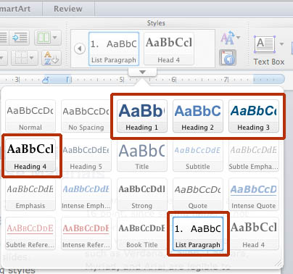
Figure 1—This screen shot shows the heading style choices that have been used in this document.
- For hyperlinks, use descriptive text such as Accessible Media Link instead of Click Here.
- Avoid presenting text as an image, such as a scan or photograph. If your page is a PDF, make sure that the text can be selected and copied.
- Write alternative texts for images (alt-tags) describing content you want students to learn. These tags will be accessible to students with impaired vision who use screen readers.
- Use large text sizes, even 14 and 16 point, since saving paper is not a priority for digital pages.
- Use shorter lines, with fewer words—10 or 11 at most. Try double columns. These are easier to read on smart phones.
- Use color combinations with strong light-dark contrast that can be differentiated by people with impaired color vision.
- Make sure all content and navigation is accessible by use of the keyboard alone, and does not require use of a mouse or trackball.
- Since people with impaired hearing cannot hear the sound in videos, use videos that have closed captioning built-in, or else inquire if you can have your school purchase captioning.
- Fonts with monoweight strokes such as Verdana, Calibri, Candara, Myriad, and Arial are legible to more readers than fonts with strokes that taper from thick to thin such as Times New Roman. This is why computer interfaces tend to use fonts with monoweight strokes.

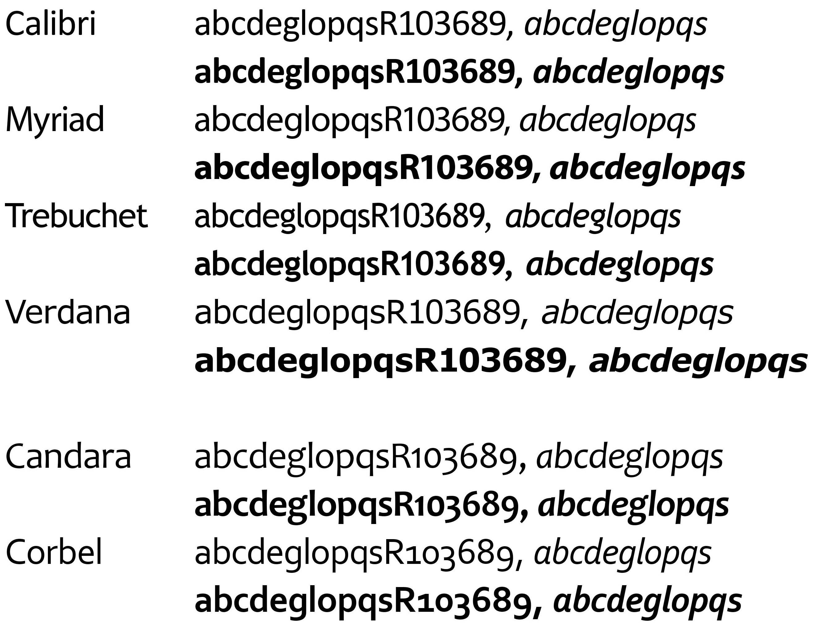
Figure 2—This image shows six recommended font families that have monoweight strokes, and styles for normal, italic, bold, and bold italic. The first four, Calibri, Myriad, Trebuchet, and Verdana, have capital numbers. The other two, Candara and Corbel, have the lower-case numbers that are good in text-heavy documents.

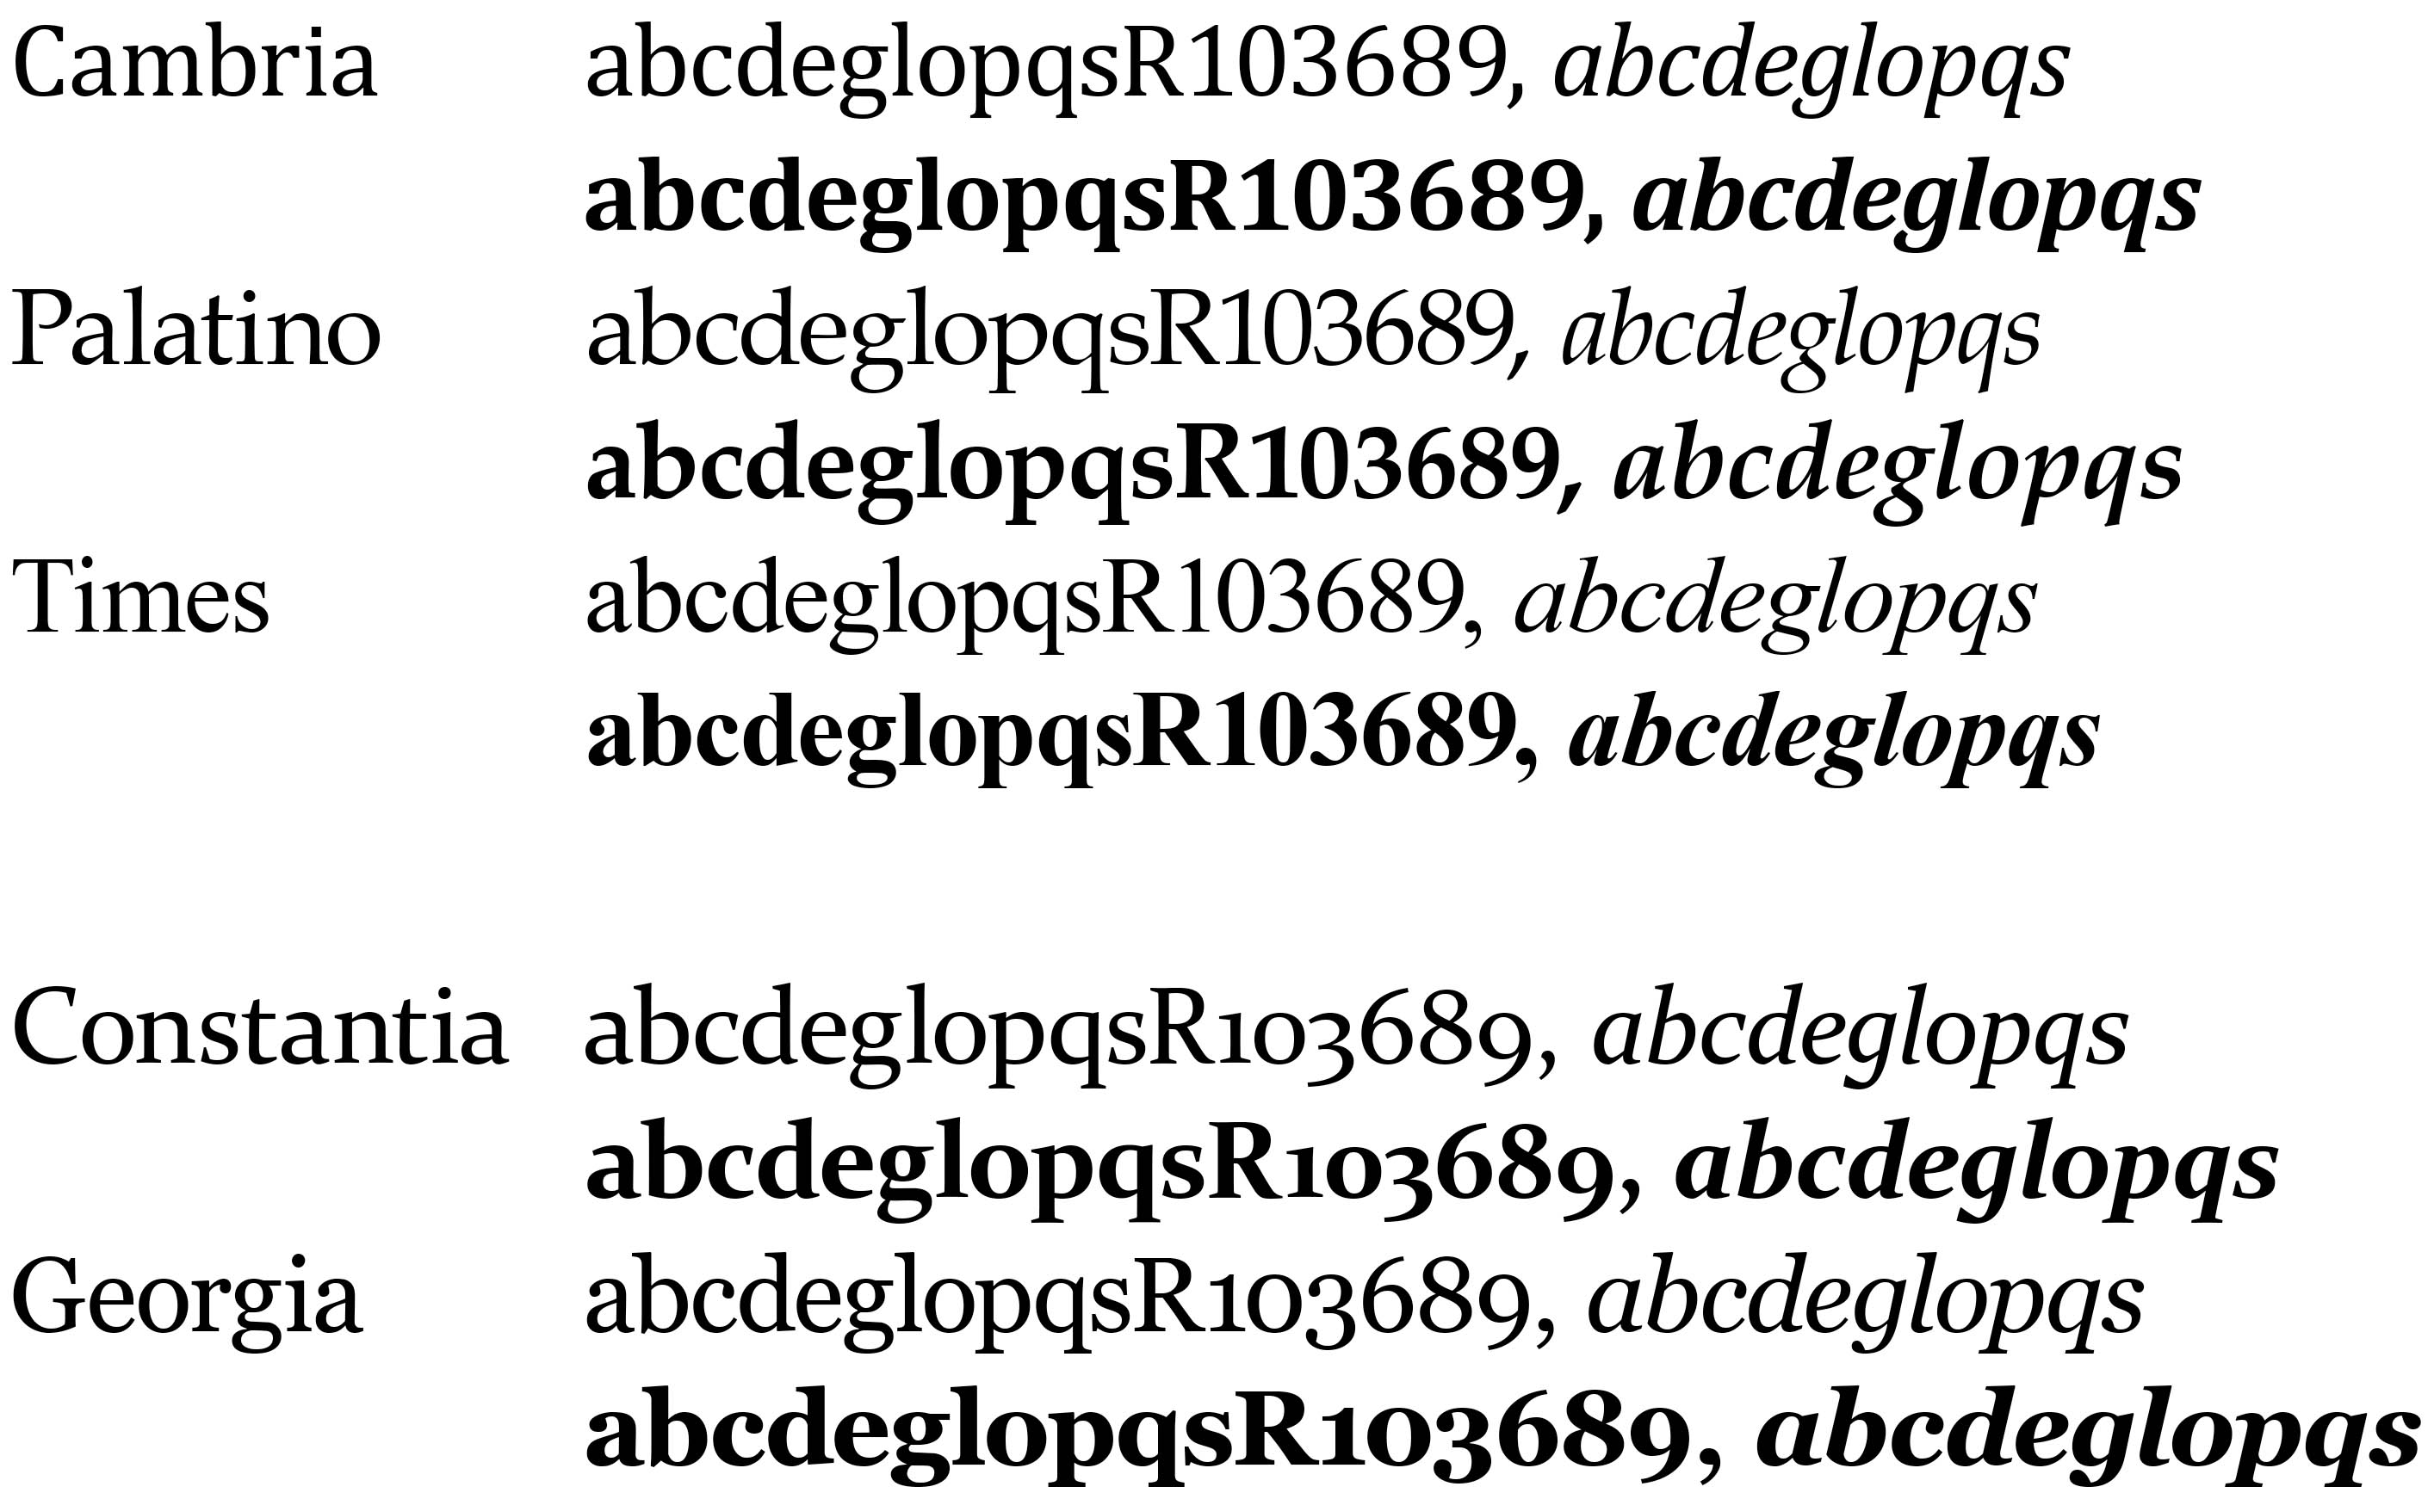
Figure 3—Tapered Stroke Fonts. Cambria, Palatino, and Times feature capital numbers. Constantia and Georgia offer lower-case numbers.
Universal Design for Learning:
Basic Concepts

- Design your document, or your course, to be accessible to a wide range of abilities and learning styles. If you are a teacher, assume that some students have invisible disabilities, but have not registered for Learning Accommodations, and won’t disclose their disability to you.
- Seek to make course content available in multiple formats, or modes, including printed text, digital text, audio, video, and images.
- Provide essential course materials such as the syllabus, assignment schedule, and assignment descriptions, both as hard copy, and as digital files posted in Blackboard or other learning management system. Students that lose hard copies will need easy access to the digital versions.
- Recognize that literacy skills and vocabularies of some students are still developing, so avoid jargon and acronyms, and provide explanations or definitions when possible.
- Try to use images to augment course content. Students understand and remember content better when delivered with a combination of words and pictures. On the syllabus, add a map, your portrait, and images of textbook covers.
- Make instructions and expectations clear for assignments. Provide examples of the kind of work the student will be doing.
- Design assignments to allow options for student expression, including writing, speaking, slide shows, video, and image-making.
- Offer outlines, glossaries, overviews, and other scaffolding tools to help students navigate the coursework.
- Allow adequate time for practice, projects, and tests.
- Let students receive feedback from each other and from you, the instructor, and then provide opportunities for students to make corrections and improvements.

